Problem 1.1

Protocol for ATM machine:
- VERIFY<account number, password>
Verifies that the account number password combination is correct.
- OPEN<account number>
Opens a transaction given the account number
- BALANCE<account number>
Retrieves the balance given the account number
- VERIFY<account number, amount>
Verifies that the given account has enough money in it
- UPDATE<account number, amount>
Updates the balance once it has been verified
- CLOSE<account number>
Closes the open transaction

The operation of the above protocol for a normal (no errors) withdrawal transaction is below.

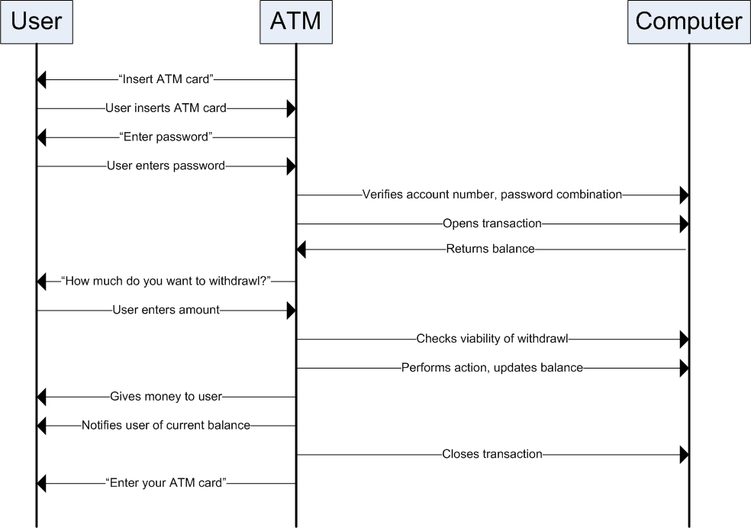
The above diagram shows the correct flow if the checks are returned correct. If either are incorrect, the ATM should notify the user and exit to the menu or go back to the start screen depending on circumstances.

It is assumed that the physical link between ATM and bank computer is always active and maintained. A TCP system should be used for guaranteed delivery of messages.

Problem 1.4
a)
2 mins
Tollbooth
Tollbooth
Tollbooth
1 hour, 100km
1 hour, 100km
200km

Time to push caravan onto highway: (10 cars)/(5 cars a min)=10/5=2 mins
Time to travel between tollbooths: (100km)/(100km/h)=1 hour

Time to go from end of tollbooth 1 to the start of tollbooth 3 with 10 cars is:
1 hour + 1 hour + 2 mins = 122 mins.

b)

1.4 mins
Tollbooth
Tollbooth
Tollbooth
1 hour, 100km
1 hour, 100km
200km

Time to push caravan onto highway: (7 cars)/(5 cars a min)=7/5=1.4 mins
Time to travel between tollbooths: (100km)/(100km/h)=1 hour

Time to go from end of tollbooth 1 to the start of tollbooth 3 with 7 cars is:
1 hour + 1 hour + 1.4 mins = 121.4 mins.

Problem 1.10

The general formula for the time for the Nth packet is (N-1)L/R where there are L bits and the transmission rate is R bps.

To find the average, sum all the terms up from 1 to N and then divide by N.
So, the general formula for the average queuing delay for a packet is:
(Σ(from j=0 to n-1)) jL/R) / N

Problem 1.19

Yes, the extra information is in things like the fact that the customer has a ticket if they are in the baggage layer. Also, if a customer is in the runway takeoff layer, then they have a ticket, their baggage is checked in, and they have passed through the gate onto the plane.

This extra information is analogous to the header information that is added to the data units as they pass through each layer in the protocol stack. However instead of the baggage check layer etc, there are application, transport, network, link and physical layers.

